Book

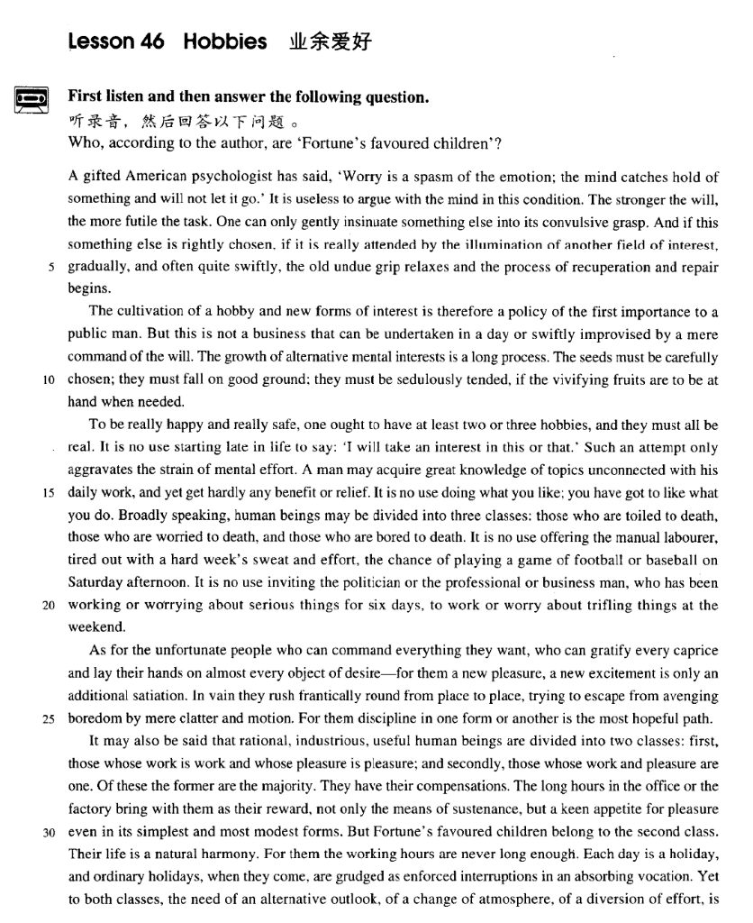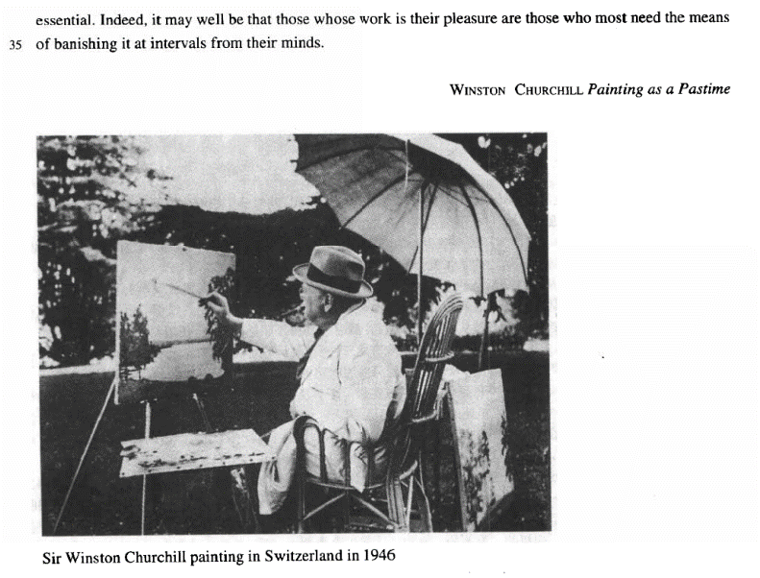

课文

A gifted American psychologist has said,'Worry is a spasm of the emotion; the mind catches hold of something and will not let it go.'

一位天才的美国心理学家曾经说过“烦恼是感情的发作，此时脑子纠缠住了某种东西又不肯松手。”

It is useless to argue with the mind in this condition.

在这种情况下，你又和头脑争吵让它松手是无济于事的。

The stronger the will, the more futile the task.

这种意志越是强烈，这种尝试越是徒劳。

One can only gently insinuate something else into its convulsive grasp.

你只能缓和而巧纱地让另一种东西进入痉挛僵持的头脑中。

And if this something else is rightly chosen, if it is really attended by the illumination of another field of interest,

如果选得合适，而且的确受到别的领域的情趣的启迪，

gradually, and often quite swiftly, the old undue grip relaxes and the process of recuperation and repair begins.

那么渐渐地，往往也是很顺利地，原先不适当的紧张就会松弛下来，恢复和修整的过程就会开始。

The cultivation of a hobby and new forms of interest is therefore a policy of the first importance to a public man.

因此，对一个从事社会活动的人来说，培养一种业余爱好和各种新的兴趣是关等重要的作法。

But this is not a business that can be undertaken in a day or swiftly improvised by a mere command of the will.

但这并非一日之功，也不是单凭一蹴而就的事。

The growth of alternative mental interests is a long process.

精神上多种情趣的培养是一个长期的过程。

The seeds must be carefully chosen; they must fall on good ground; they must be sedulously tended, if the vivifying fruits are to be at hand when needed.

要想在需要的时候可随手摘取充满生机的果实，那就必然从选良种做起，然后将其植入肥沃的土地，还需要勤勉地护理。

To be really happy and really safe, one ought to have at least two or three hobbies, and they must all be real.

一个人要想真正感到幸福和平安，至少应有两三种爱好，而且都比较实际。

It is no use starting late in life to say: 'I will take an interest in this or that.'

到了晚年才开始说：“我会对这些人或那个人发生兴趣”，

Such an attempt only aggravates the strain of mental effort.

已没有用了。这种愿望只能加剧精神紧张。

A man may acquire great knowledge of topics unconnected with his daily work, and yet get hardly any benefit or relief.

一个人可能会获得与其日常工作无关的某些课题的渊博知识，而没有从中得到什么实益或宽慰。

It is no use doing what you like; you have got to like what you do.

干你所喜欢的事是没有用的，你喜欢你所干的事。

Broadly speaking, human beings may be divided into three classes:

泛泛地说，人可以分为3类：

those who are toiled to death, those who are worried to death, and those who are bored to death. It is no use offering the manual labourer, tired out with a hard week's sweat and effort the chance of playing a game of football or baseball on Saturday afternoon.

劳累至死的人、忧虑至死的人、无聊至死的人。对于流汗出力干了一周苦活的体力劳动者来说，让他们在星期六下午再踢足球或打垒球是不合适的；

It is no use inviting the politician or the professional or business man, who has been working or worrying about serious things for six days, to work or worry about trifling things at the weekend.

同样，对于为严肃的公务操劳或烦恼了6天的政界人士、专业人员、商人来说，在周未再让他们为琐事而动脑子和忧虑也是无益的。

As for the unfortunate people who can command everything they want,

至于那些能任意支配一切的“可怜的人”，

who can gratify every caprice and lay their hands on almost every object of desire -- for them a new pleasure a new excitement is only an additional satiation. In vain they rush frantically round from place to place, trying to escape from avenging boredom by mere clatter and motion.

他们能够恣意妄为，能染指一切追求的目标。他们到处奔乱跑，企图以闲聊和乱窜来摆脱无聊对他们的报复，

For them discipline in one form or another is the most hopeful path.

但这是徒劳的。对他们来说，用某种形式的纪律约束他们一下才能有希望使他们走上正道。

It may also be said that rational, industrious, useful human beings are divided into two classes: first, those whose work is work and whose pleasure is pleasure; and secondly, those whose work and pleasure are one.

也可以这样说，理智的，勤劳的、有用的人可以分为两类：第一类是他分清工作是工作，娱乐是娱乐的人；第二类人的工作和娱乐是一回事。这两类人当中，第一类人是大多数，他们能够得到补偿。

Of these the former are the majority. They have their compensations. The long hours in the office or the factory bring with them as their reward, not only the means of sustenance, but a keen appetite for pleasure even in its simplest and most modest forms.

在办公室或工厂里长时间工作给他们带来了酬劳，这不仅是谋生的手段，而且还带来了寻找乐趣的强烈欲望，那怕是最简单的、最低等的乐趣。但是，命运之神的宠儿是第二类人，

But Fortune's favoured children belong to the second class. Their life is a natural harmony.

他们的生活是一种自然的和谐，对他们来说，工作时间总不会太长，

For them the working hours are never long enough. Each day is a holiday, and ordinary holidays, when they come, are grudged as enforced interruptions in an absorbing vocation.

每天都是假日，而通常的假期来到，他们却惋惜这假期强制打断了他们埋头从事的工作。

Yet to both classes, the need of an alternative outlook, of a change of atmosphere of a diversion of effort, is essential.

然而对这两种人来说，都需要换一换脑子，改变一下气氛，转移一下注意力，这是不可缺少的。

Indeed, it may well be that those whose work is their pleasure are those who most need the means of banishing it at intervals from their minds.

说实在的，把工作当作享受的那些人最需要每隔一段时间把工作从头脑中撇开。

词汇讲解

Lesson 46 Hobbies

gifted ['gɪftɪd]

adj. 有天才的，有天赋的

gifted gift talented talent natural / born He is a ~ leader.

have a gift / an aptitude for … Mozart had a gift for music.

Mozart had an aptitude for music. insinuate [ɪn'sɪnjueɪt]

v. 暗示；使悄悄地潜入

What are you trying to insinuate? Are you insinuating that I smell?

imply suggest intimate hint insinuation implication suggestion intimation hint

insinuate v. to get into a situation or position by behaving in a way that is not sincere 使悄悄地潜入……之中

insinuate A into B

Over the years she insinuated herself into the great man’s life.

He has ways of insinuating his ideas into the brains of his followers. grip [grɪp]

n. 紧握，抓牢；理解，掌握

grip / grasp

Don’t loosen your grip on the rope or you’ll fall. I tightened my grip on the handrail.

She has a sound grip / grasp of English. gripping / absorbing

a gripping / absorbing detective novel aggravate ['ægrəveɪt]

v. 使恶化

The pain will be aggravated by coughing. compound

Their domestic problems were compounded by stress at work. exacerbate

Ironically, the government’s reassurances may have exacerbated fear about the disease.

deteriorate degenerate go downhill

relieve alleviate

ameliorate

improve better enhance gratify ['grætɪfaɪ]

v. 满足，使满意

be gratified to see / hear / learn ...

John was gratified to see the improvement in his mother’s health. gratify one’s whims / caprices

satiate …

Nothing seems to satiate people’s need for gossip. cater to / for…

gratification satisfaction satiation

avenge [ə'vendʒ]

v. 为……报仇

He has devoted the past five years to avenging his daughter’s death. avenge oneself on sb.

She avenged herself on her father’s killers. revenge

revenge one’s death revenge a defeat revenge oneself on sb.

Eric wanted to revenge himself on John for the insult. retaliate

The British government retaliated by breaking off diplomatic relations. retaliate against …

The army began to retaliate against the civilian population. get / pay sb. back (for…)

This time you beat me, and sometimes I’ll get / pay you back (for this). get even

get even with sb.

What can I do to get even with him? grudge [ɡrʌdʒ]

v. 怨恨，不愿意

grudge v. feel resentful about sth; do or give sth. very unwillingly 怨恨， 不愿意

grudge + n. / doing

He grudges her earning more than he does. He grudges paying taxes.

He grudges the money he pays in tax.

There are times when we would willingly give everything we possess to save our lives, yet we might grudge paying a surgeon a high fee for offering us precisely this service.

grudging reluctant unwilling grudge n. 恶意，怨恨

have / bear / hold a grudge 怀恨在心

She has a bad memory.

She's quick to forgive people.

Her feelings are easily hurt.

She doesn't get angry very often.

W: I wish I hadn’t hurt Mary’s feelings like that. You know I’ve never meant to.

M: The great thing about Mary is that she doesn’t hold a grudge. By tomorrow she’ll have forgotten all about it.

Q: What does the man say about Mary? Answer: (B) She's quick to forgive people.

Winston Churchill(1874~1965)

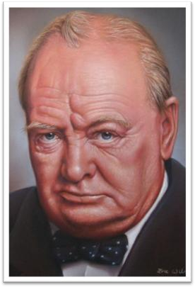

British politician and Prime Minister, widely regarded as the greatest British leader of the 20th century.

His courage, decisiveness, political experience and enormous vitality

enabled him to lead the country through the Second World War.

Churchill was also known for the many books on British history and politics he wrote throughout his life.

His command of the English language not only made him a great orator but earned him the Nobel Prize for literature in 1953.

A gifted American psychologist has said, 'Worry is a spasm of the emotion; the mind catches hold of something and will not let it go.'

catch hold of …

grip / seize / clutch / clasp

get hold of: find sb. or obtain sth. Where can I get hold of some stamps?

Could you tell me how I can get hold of a doctor? let … go = release

Please release me, let me go. For I don't love you anymore.

To waste our lives would be a sin. Release me and let me love again. It is useless to argue with the mind in this condition.

it is useless / futile / pointless to do / doing … it’s a waste of time doing …

it’s no use doing …

there is no use (in) doing … it’s no good doing …

there is no good doing … there is no point (in) doing …

The stronger the will is, the more futile the task will be. insinuate A into B

And if this something else is rightly chosen, if it is really attended by the

illumination of another field of interest, gradually, *and often quite swiftly,*

the old undue grip relaxes and the process of recuperation and repair begins.

attend the meeting attend college

She is attended by a 24-hour nursing staff. attend to sth. = deal with sth.

The queen was attended by her ladies-in-waiting. The occasion was attended by an air of sadness.

The cultivation of a hobby and new forms of interest is therefore a policy

*of the first importance* to a public man. cultivation cultivate

Most of the world’s fertile land is already cultivated. cultivate vegetables / peonies

cultivate v. develop / build up

cultivate hobbies cultivate a love of art

cultivate good study habits Honesty is the best policy.

This is a mission of importance. of the first importance

of leading / primary / paramount importance of vital / crucial importance

of secondary importance of equal importance

But this is not a business that can be undertaken *in a day* or swiftly improvised *by a mere command of the will*.

alternative adj. different from the one you have and can be used instead

其他的，另外的

Have you any alternative suggestions? alternative mental interests

alternative to sth.

Is there a viable alternative to surgery? have no alternative but to do…

I have no alternative but to report him to the police. alternate adj. 轮流的，交替的

I visit him on alternate Sundays.

The seeds must by carefully chosen; they must fall on good ground; they must be sedulously tended, if the vivifying fruits are to be at hand when

needed.

I always keep a dictionary close at hand. The signature must be given by hand.

The work is in hand, and will soon be completed. They are always on hand whenever you need them. I can’t remember his phone number off hand.

*To be really happy and really safe*, one ought to have at least two or three hobbies, and they must all be real.

It is no use starting *late in life* to say: 'I will take an interest in this or that.'

it is no use doing

It’s no use crying over spilt milk. take an interest in …

= be interested in …

strain: stress / tension / pressure

A man may acquire great knowledge of topics unconnected with his daily work, and yet get hardly any benefit or relief.

find a temporary relief permanent relief

to my great relief

give immediate relief from pain

It is no use doing what you like; you have got to like what you do. Antimetabole 回环 / 倒复

Eat to live, not live to eat.

— Socrates

Forty is the old age of youth, fifty is the youth of old age.

— Victor Hugo

Where there is marriage without love, there will be love without marriage.

— Benjamin Franklin

The reasonable man adapts himself to the world, the unreasonable man persists in trying to adapt the world to himself. Therefore, all progress depends on the unreasonable man.

— G. B. Shaw

So let us begin anew —remembering on both sides that civility is not a sign of weakness, and sincerity is always subject to proof. Let us never negotiate out of fear, but let us never fear to negotiate.

— John F. Kennedy

And so, my fellow Americans, ask not what your country can do for you; ask what you can do for your country.

— John F. Kennedy

*Broadly speaking*, human beings may be divided into three classes: those

who are toiled to death, those who are worried to death, and those who

are bored to death. broadly adv. generally generally speaking

Strictly speaking, the whale isn’t a fish. Judging from his face, he must be ill.

To make a long story short, he wanted money, and tried to get it without working.

But as they are about to return, an unprecedented storm descends on the area and blocks their way home. To make things worse something unexpected happens.

toil v. to work very hard for a long period of time 长期辛苦工作，苦干

Farm laborers have to toil in the fields all day. He was toiled to death.

I have nothing to offer, but blood, toil, tears and sweat.

Broadly speaking, leaders may be divided into two classes: those who are created by demands placed upon them, and those who are ‘self-created’ through hard work and achievements. Fortune’s favored children belong to the former, whereas the latter, I believe, are the majority.

It is no use offering the manual labourer, tired out with a hard week's

sweat and effort, the chance *of playing a game of football or baseball on*

*Saturday afternoon*.

be tired out / exhausted

offer sb. sth. / sth. to sb.

It is no use inviting the politician or the professional or business man,

who has been working or worrying about serious things for six days, to

work or worry about trifling things at the weekend.

As for the unfortunate people who can command everything *they want*, who can gratify every caprice and lay their hands on almost every object

of desire—for them a new pleasure, a new excitement is only an additional satiation.

command v. 掌管，掌握

command great wealth command a large vocabulary gratify v. satisfy

get / lay one’s hands on sth: obtain sth. 得到某物

I would read any book I could get / lay my hands on.

get / lay one’s hands on sb: to catch sb. you are angry with 抓住惹你生气的人

Just wait till I get / lay my hands on you!

*In vain* they rush frantically round from place to place, trying to escape from avenging boredom by mere clatter and motion.

in vain: without success in spite of your efforts 徒劳

Obviously all her complaints were in vain. Police searched in vain for the missing boy.

to no avail

He rebooted my systems several times, but to no avail.

It may also be said that rational, industrious, useful human beings are divided into two classes: first, those *whose work is work and whose*

*pleasure is pleasure*; and secondly, those *whose work and pleasure are*

*one*.

sweeping / overwhelming / absolute / vast majority small / narrow majority

be in the majority

Surveys indicate that supporters of the treaty are still in the majority. Of course, the former are in the majority.

predominate

In older age groups women predominate because men tend to die younger.

Of course the former predominate.

They have their compensations for their hard work.

The long hours in the office or the factory bring *with them as their reward*, not only the means of sustenance, but a keen appetite for pleasure *even in its simplest and most modest forms*.

favour / favor vt. 喜爱偏爱 = prefer

She favors her youngest child. Fortune’s favored children 天之骄子

Their life is naturally harmonious.

Each day is a holiday, and ordinary holidays, when they come, are grudged as enforced interruptions *in an absorbing vocation*.

be grudged as sth. 被当做……而耿耿于怀，拒绝接受

He is spending his precious vacation in a country retreat and any visit now will be grudged as disturbance to his privacy.

enforce v. 强迫人们服从，执行

The main role of the police is to uphold and enforce the law. enforced adj. 被迫的，自己无法控制的

enforced absence

enforced isolation vocation

job profession occupation vacation

Yet to both classes the need *of an alternative outlook*, *of a change of*

*atmosphere*, *of a diversion of effort*, is essential.

diversion n. change in the direction or use of sth. 改变（方向或用途）

the diversion of a ship the diversion of a stream

This would result in massive diversion of funds.

Indeed, it may well be that those whose work is their pleasure are those who most need the means of banishing it *at intervals* from their minds.

It may well be that …

Indeed, it may well be that those who … are those who most need … at intervals …

造句：其实，很可能那些平时几乎不看病的人最需要每隔一段时间从

工作中抽空 (take time off from work) 做一次全面的体检 (have a thorough checkup)。

Indeed, it may well be that those who hardly see a doctor are those who most need take time off from their work at intervals to have a thorough

checkup.